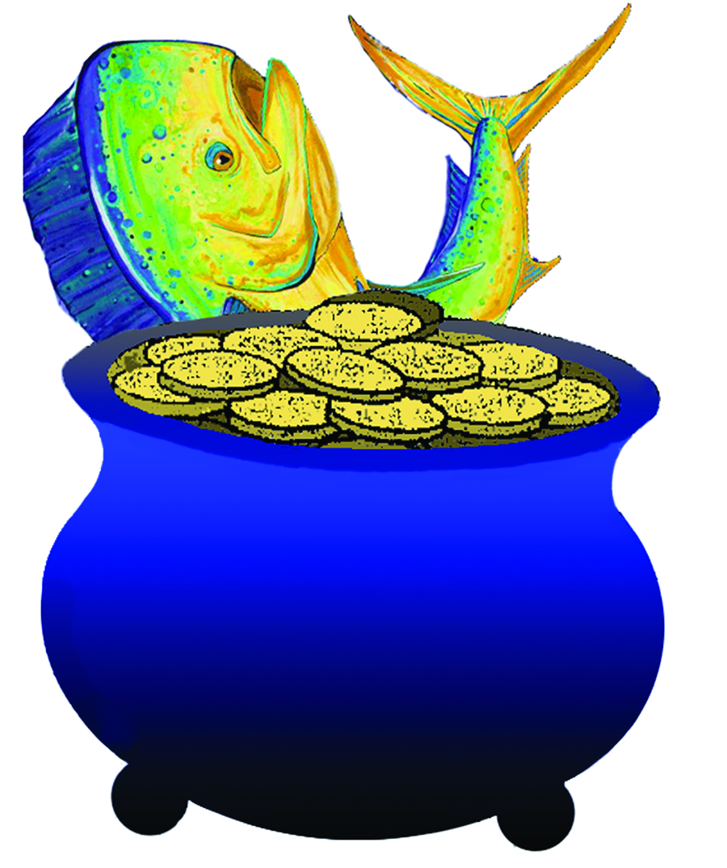
CAYMAN BRAC JACKPOT
FISHING TOURNAMENT
MAY 17TH – 19TH, 2019

Heaviest Eligible Fish caught in the Sister Islands – US$4,000.00.
Lawford Tatum Memorial Prize for Heaviest Dolphin caught in the Sister Islands – US$2,000.00.
Wes Verges Memorial Prize for Heaviest Wahoo caught in the Sister Islands – US$2,000.00.
Steve Foster Memorial Prize for Most Marlin Releases – US$2,000.00
Heaviest Grand Slam – US$1,000.00
2nd Heaviest Grand Slam – US$500.00
Heaviest Wahoo – US$2,000.00
2nd Heaviest Wahoo – US$1,500.00
3rd Heaviest Wahoo – US$1,000.00
Heaviest Dolphin – US$2,000.00
2nd Heaviest Dolphin – US$1,500.00
3rd Heaviest Dolphin – US$1,000.00
Heaviest Yellowfin Tuna – US$2,000.00
2nd Heaviest Yellowfin Tuna – US$1,500.00
3rd Heaviest Yellowfin Tuna – US$1,000.00
Lady Angler Heaviest Eligible Fish – US$1,000.00
Junior Angler Heaviest Eligible Fish – US$500.00
ENTRY FEE: CI$300.00 PER BOAT OF UP TO 4 ANGLERS, ADDITIONAL ANGLERS
CI$100 EACH
REGISTRATION: THURSDAY, MAY 16TH , 6:00PM TO 7:30PM AT CAPTAIN’S TABLE,
CAYMAN BRAC & THE BARCADERE (MARINA), GRAND CAYMAN
WEIGH STATION: GOVERNMENT DOCK, THE CHANNEL, CAYMAN BRAC &
THE BARCADERE (MARINA), GRAND CAYMAN 4:00 – 5:00PM
RADIO: CHANNEL 10 IN CAYMAN BRAC &
CHANNEL 28 IN GRAND CAYMAN
FISHING HOURS: 7:00AM TO 4:00PM
PRIZEGIVING: SUNDAY, MAY 19TH 7:30PM, THE CAYMAN BRAC BEACH RESORT,
CAYMAN BRAC

IGFA RULES APPLY – NO WIRE LINES
Registered boats/anglers are allowed to fish in Grand Cayman for all prizes EXCEPT
‘Heaviest Eligible fish caught in the Sister Islands’ &
‘Lawford Tatum Memorial Prize for Heaviest Dolphin caught in the Sister Islands’ (excludes Pickle Bank) &
‘Wes Verges Memorial Prize for Heaviest Wahoo caught in the Sister Islands’ (excludes Pickle Bank).
Minimum Eligible Weight: Wahoo and Dolphin 15 lbs and Yellowfin Tuna 20 lbs
Further Information Contact – Kenny Ryan 925-3844 / Heather Bodden 916-3574 / Donna Sjostrom 916-0179

